Tragedy of the Commoners
Tatiana Bailey, Ph.D.

Back in 2016, I wrote an article for the Colorado Springs Business Journal, which is now back in circulation. (Welcome back, CSBJ.) I was thrilled and give kudos to Amy Sweet, the chief editor at the time, for whole heartedly accepting my economics articles, which sometimes deviated from economics into the fields of health care, childcare and even personal stories about elder care. Here we are almost 10 years later, and it seems that all of those topics are even more salient. A younger person would say they’ve all gone viral. The topics, specifically health care, have even gone violent, as with the tragic murder of the United Healthcare CEO Brian Thompson. We’ve all heard and read plenty about it, but I still feel the discourse in health care is centered around symptoms and not causes. As such, I am resurrecting my almost-decade old article that focuses on a seminal 1963 article from Kenneth Arrow, considered the “father of health care economics.” I end with a discussion about the December (CEO) murder and the indictment of Luigi Mangione.

Health care is not a typical good or service, in an economic sense, which makes it a square peg in a round hole. Health care evokes strong emotions and opinions because it is a highly personal commodity that is at the core of our very existence. This alone firmly places health care into a category all its own, not subject to the normal assumptions we can make about how to produce, distribute or regulate it. The various historical attempts to treat health care as a standard economic commodity is perhaps what has created its very demise. Could a different approach be to acknowledge health care’s uniqueness and to use its distinct attributes as the guiding principles for its provision?

Let us start with the basic facts. Health care is consuming 17% of U.S. gross domestic product (GDP), or $3 trillion, per year. This is more than we spend on education (5.4% of GDP) and the military (4.7%) combined, according to the World Bank. These costs are the highest in the developed world, more than double the Organization for Economic Cooperation and Development average, and yet our outcomes don’t justify the costs. These costs have been escalating relentlessly both before and after the signing of the Affordable Care Act (ACA). In fact, prior to the initiation of government into health care via Medicare and Medicaid in 1965, costs were rapidly escalating. They were increasing so quickly that the elderly and the indigent were becoming destitute trying to pay for health care while many hospitals were becoming insolvent trying to provide care for the sick and dying showing up at their emergency rooms (but unable to pay). Private hospitals were, in fact, a strong lobby for Medicare and Medicaid. The moral undertone of denying care to the elderly and indigent was also a driving force, especially for a country that was prosperous and influential in the world arena.

In addition to the moral undertones are the other attributes that the economist Kenneth Arrow highlighted as red flags back in a 1963 article. The demand for health care is highly unpredictable because we don’t usually know when we will need it the most. In the economics vernacular, this makes health care “inelastic,” meaning people will pay almost anything to obtain it when they really need it. This clouds a logical price structure. Outcomes are not guaranteed since everyone is different, and you can’t really return the good if you don’t like the outcome. This introduces another distortion: malpractice. The high costs of malpractice insurance that physicians have to pay get passed right back to the consumer in the form of higher premiums. Most other countries have tort limits. The supply of health care is restricted by the (private) American Medical Association by keeping the number of medical schools, and therefore medical graduates, low. Because utilization is highly variable between individuals and costs can be so high for even one health episode, there is a third-party payer system (insurance). Most would agree that insurance is necessary, yet it introduces a distortion as well. Once we pay premiums, we can consume at will. We do not pay per unit of service, often don’t know what the total cost is and therefore tend to overconsume services. There is significant cost shifting in health care because any time an individual utilizes health care services but cannot pay, providers negotiate higher insurance premiums for the insured to recover their costs.

No one would argue that technology is a bad thing, and yet, improvements in technology are incredibly costly. Tied to this is the relative ignorance non-health-care professionals feel in terms of when to optimally use technology or just about any health care service. This is called informational asymmetry, and it makes most of us willing consumers of whatever the doctor might recommend. Given that doctors can be sued at will, and that they are often compensated by levels of patient utilization, their incentive is to provide maximum care. The U.S. also has an inverse ratio of specialists to primary care physicians and specialists tend to charge more for office visits and order more complex tests.

All of these product anomalies highlighted by Arrow have been driving up costs for decades; however, we now have an even greater hurdle — unhealthy lifestyles. Fully 75% of health care costs are for preventable, chronic maladies mostly tied to being overweight or obese (Centers for Disease Control and Prevention). Sixty-six percent of the U.S. population is either overweight or obese. This is the elephant in the room, and it is dictating demand more so than any other factor. This attribute and the implicit uniqueness of health care does not really call for discourse on whether we should have a government-run or privately-run health care system. It calls for a paradigm shift in how we provide health education, how we alter health behavior and how we move from the expensive curative model to a preventive model. It calls for personal awareness and responsibility in terms of our own health care utilization. If these tenets are the foundation of a health care system, huge strides can be made in terms of quality of life, in terms of affordability and therefore in terms of accessibility for all.

As brief updates to the above article from 2016, total U.S. health care expenditures in 2023 reached $5 trillion, which is still about 17% of total GDP. The Centers for Medicare and Medicaid Services project expenditures to reach $7.2 trillion by 2032, accounting for 20% of GDP. Another update: the percentage of Americans who are overweight or obese is now 74%. Also, Kenneth Arrow’s notion of insurance creating moral hazard where insurance pays, so we consume (health care) at will, used to be largely true. But the big update here is that moral hazard and the proclivity towards overconsumption of health care came into play in a big way both on the consumer and supplier (physician) side. So much so that insurance companies became ruthless gatekeepers to keep costs down. Enter Luigi Mangione.

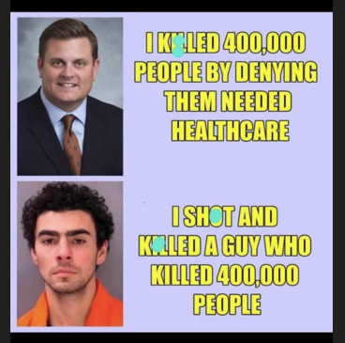
The murder of Brian Thompson was shocking, but the reaction to the murder was staggering. I believe the vitriolic reaction was in many ways a statement about capitalism. I admittedly have an aversion to social media, but my kids keep me apprised. The tenor of the vindication can be summed up by images showing Thompson with the tagline, "I killed 400,000 people by denying them needed healthcare," and Mangione's image with "I shot and killed a buy who killed 400,000 people." Mangione became a hero to many as recently as Jan. 19 when there were calls for President Joe Biden to pardon Mangione.

Police in New York and other major cities have described an increase in threats aimed at corporate leaders, including “Wanted” posters in Manhattan that showed the faces of other executives next to a crossed-out photograph of Thompson’s face. What does this say about our economic system that such a large proportion of Americans vilify the C-suite and say they “deserve” what’s coming to them? I thought these CEOs had achieved the American Dream. Yet many Americans not only lament, but also vehemently loathe, corporate power.

There were notable differences in the homicide reactions by age cohort where younger people seemed to “side” with Mangione much more so than older people. Chalk that up to older people having a lifetime of work and experiences that help them better understand nuance. But isn’t it also a likely factor that the financial situation of young people today is a factor? A 2022 Gallup poll found that 42% of Americans expect today’s young people to have a better life than their parents, a significant decline from 71% in 1999.¹ In terms of total wealth accumulation, the stats support this notion with approximately 62% of boomers having become homeowners by age 35, whereas only 49% of millennials have achieved this milestone.² It’s tough for young adults to save for a home (which is the primary mechanism for wealth accumulation) when they have student loans (61% do), high apartment rents, high health insurance costs (after age 26 if their parents had access to health care and covered them), and if they are ambitious, high child care costs. Aside: the U.S. fertility rate is now well below replacement level (2.1) at 1.6 children per couple. Out of five kids, my husband and I only paid a deductible for our last child and maybe five would not have happened with the large deductibles and copays now in place. The average deductible is roughly $2,000 now, although I hear most people quote higher amounts. Whatever the exact amount, $1,000 is very different to a young person without a home or retirement account than it is for a Gen Xer or boomer. Seemingly, key aspects of our capitalist model are not working for many young adults in the U.S., and we heard that in spades after the murder of Thompson.

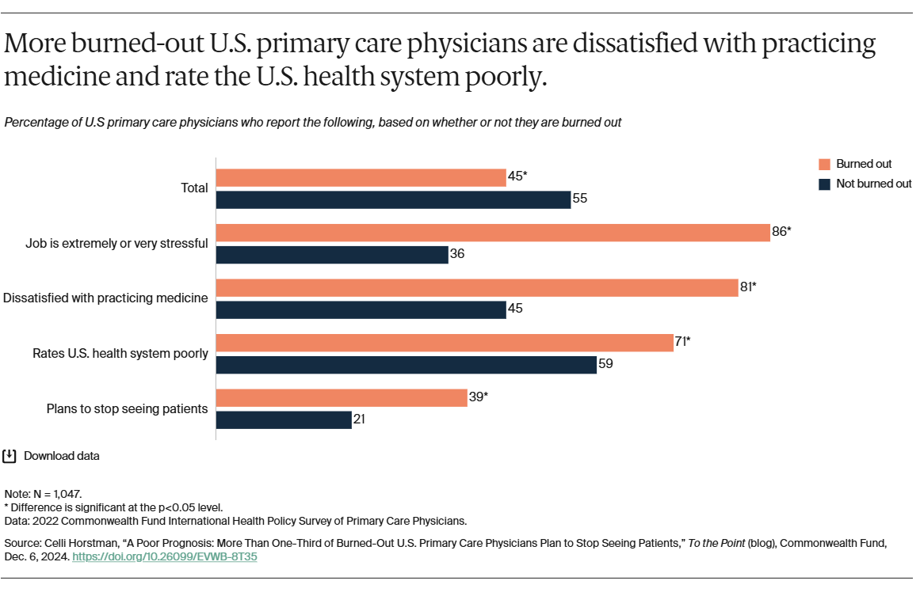
When I was in graduate school in the ’90s and the health care debate was coming to the forefront, many people blamed doctors, citing high salaries. The conversations I have today with physicians elicit my sympathy. Many doctors lament the number of patients they have to see in a day hindering their ability to provide proper care while driving themselves into the ground in the process. Physicians express exasperation at the complexity of the insurance process, and I hear as much if not more consternation about private insurers. No wonder more than one-third of primary care doctors say they plan to leave the profession.³ The graph above shows other 2022 statistics including the 71% of doctors who rate the U.S. health system poorly. What does it say when the suppliers (doctors) think the U.S. health care system is broken? Seems to me that doctors are also largely the victims of the insurance industry. Some doctors have left the traditional insurance system and started their own practices where patients pay a monthly amount for more personalized, less-rushed care. Patients can then purchase catastrophic insurance separately and at a lower cost. That’s my nod to capitalism, although I’ve heard this isn’t a perfect solution either. Which brings us full circle to Arrow’s stance that health care is unusually complicated and not conducive to the laws of supply and demand.

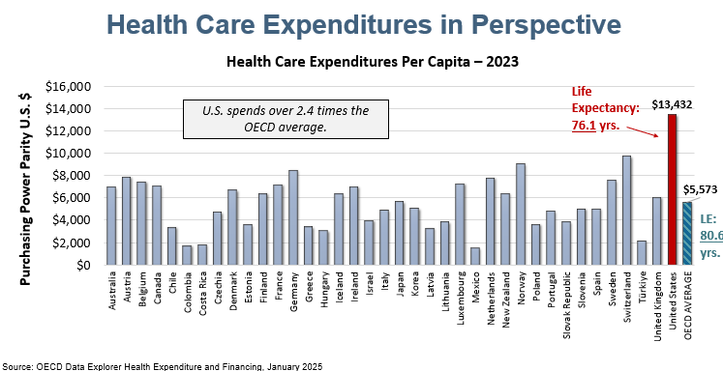
The suboptimal outcomes of the current U.S. health care system are egregious enough that we seemingly need someone to blame. The U.S. health care expenditures and life expectancy in the adjacent chart are case in point. So, if we don’t blame the CEOs of large health insurance companies nor doctors nor hospitals, who do we blame? Who is accountable for the millions of people who are denied care even when they allegedly are “insured”? Who is accountable for the poor quality of life and even the deaths that occur as a result? Who do we blame for the nearly 50% of all household bankruptcies that are attributable to medical debt and estimated 23% who have unpaid medical bills?⁴ And why did I grow up with hopes and expectations of homeownership and children while young people today scoff at those notions? Absolutely nothing validates the murder of Thompson, but something isn’t working right when many people think first about their own experiences with the dysfunctional U.S. health care system even before they think about the loss felt by Thompson’s family. They think less about the CEOs who now legitimately fear for their safety. I don’t think that Americans are inherently vengeful against prosperity and success. Many just seem to feel the economic system they live in works against their prosperity and success.

Tatiana Bailey is the founder of Data-Driven Economic Strategies. Other articles, TV segments, DDES monthly economic dashboards and how to sponsor their work can be found at ddestrategies.org.

